**Technical Document**

**Context and Story:**

Dependency and Mapping:

According to Whitepaper AWS. 1A Phased Strategy for Migration: Step by Step Guide shown below.

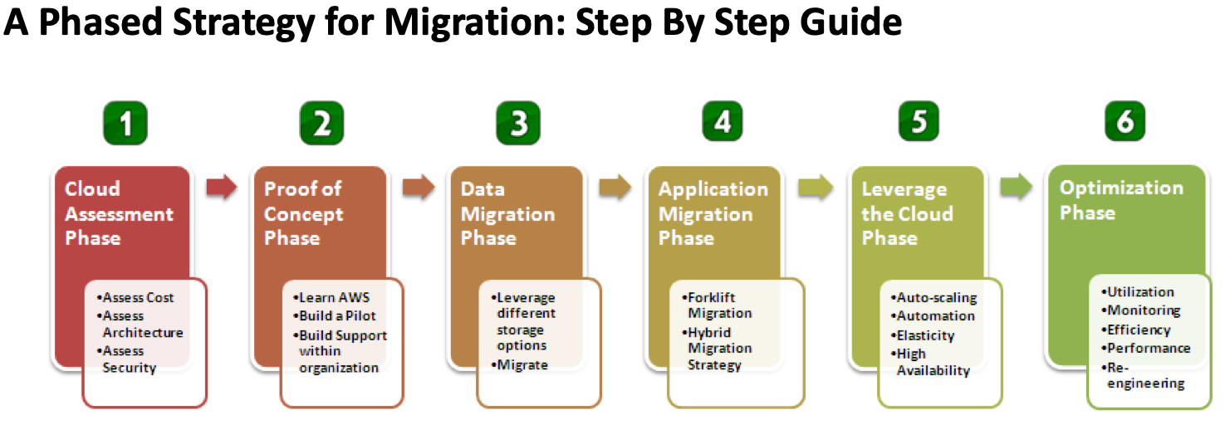

The phases comprising of cloud assessment, proof of concept and moving your data and leveraging the cloud are three phased strategy aspects for migration that will be used in this technical document, leveraging financial assessment (TCO calculation), aspects of security and compliant assessment, identify tools that can be reused and the tools that need to be built perhaps hybrid. As well as Migration including or not fileservers to S3, RDBMS to EC2 + EBS, MySQL to Amazon RDS. Moving apps strategies including Forklift migration, hybrid migration, cloud-aware layers of code or create AMI’s for each component.

Pricing of migration, and of one monthly will be shown below as well.

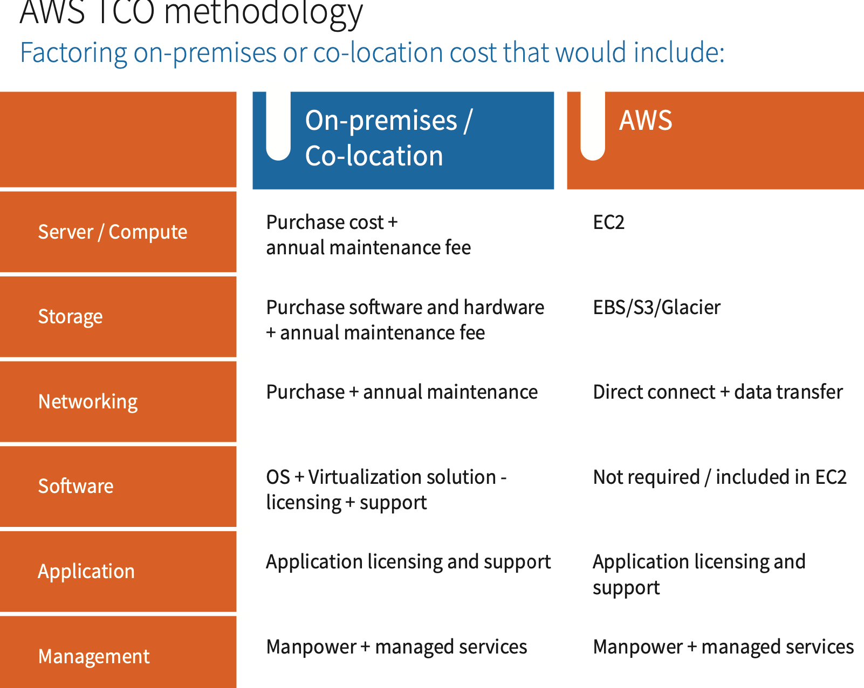

So the challenges:

Data storage, data preparation, validation, transfer marshalling. 2

Data storage: - capacity of data, protocol used, file system used to migrate, pushing data to cloud without consider do not consider cost alone. Depends on service, ebs, s3 pricing plan, efs or fsx need to calculate, pricing documentation estimated charges between two premises.

Data preparation: filter unwanted data, prioristse which data is important, basis on first application the second application and that is very important step

Analysis and Planning based on the details of assets, dependencies, firewall rules.

According to the asset list and the dependencies, the following has been understood.

Dependencies:

* PETRA App Servers (S006 to S009) depend on the Database Servers (S012 and S013).
* The Web Servers (S002 to S005) depend on both the App Servers and the Shared Storage (SAN01).
* All servers have a dependency on the Active Directory server for access.

Flow of communication:

* PETRAweb communicates with PETRAapp over port 9000.
* WebServers use HTTPS to the internet.
* All servers need access to the company's Active Directory server on all ports.

To figure out the architecture of the migration following questions need to be addressed (according to white paper mentioned above migration)

* Which business applications should move to the cloud first
* Does the cloud provide all of the infrastructure building blocks we require
* Can we reuse our existing resource management and configuration tools
* How can we get rid of support contacts for hardware, software and network

According to the whitepaper:

A dependency tree and classification chart should be done. Where it

“performs a thorough examination of the logical constructs of your enterprise applications and start classifying your applications based on their dependencies, risks, and security and compliance requirements.

Identify the applications and their dependencies on other components and services. Create a dependency tree that highlights all the different parts of your applications and identify their upward and downstream dependencies to other applications. “

As you have provided your application assets with all your systems. The following has been produced:

Petra CRM:

According to the information provided below showcases the classification chart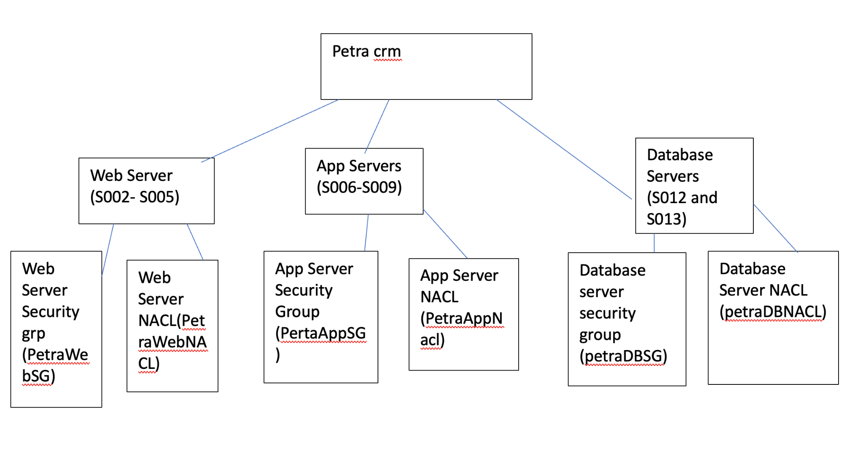

* Public Subnet (Web Servers):
  + Security Group: PetraWebSG
  + Network ACL: PetraWebNACL
* Private Subnet (App Servers):
  + Security Group: PetraAppSG
  + Network ACL: PetraAppNACL
* Private Subnet (Database Servers):
  + Security Group: PetraDBSG
  + Network ACL: PetraDBNACL

Migration Strategy:

* The migration strategy depends on complexity and criticality of the application, an appropriate migration strategy is chosen which can involve various aspects such as rehosting, refactoring, or rebuilding the application.
* Begin migration process by replicating the on-premise application to the cloud. This may involve tools such as AWS Database Migration Service or AWS Server Migration Service.
* VPC shown below is in accordance to defining the warriors aspects needed as follows: ip address range, subnets, routing tables, and security groups that the PETRA CRM VPC will use.
* Examples shown below.

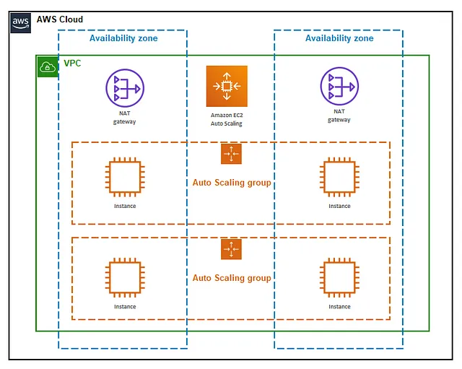

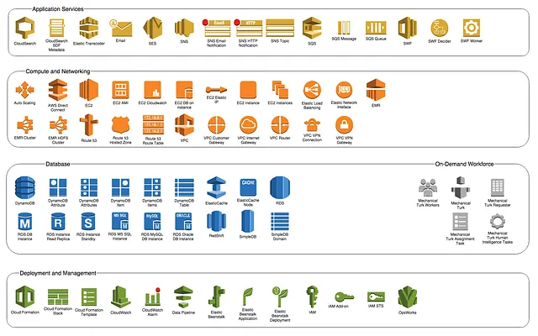

Internet Gateway:

* Allows communication between resources in your VPC and the internet.

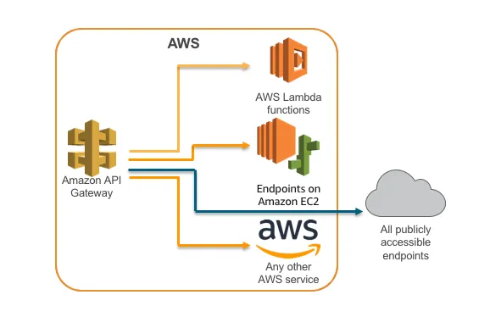

According to the table below

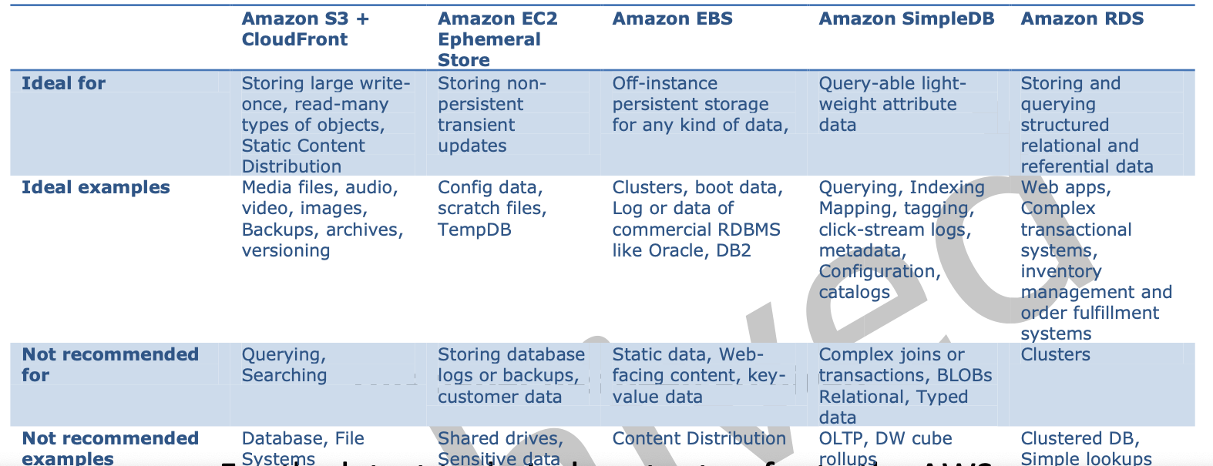

Choosing AWS services and various Storage Options available in the AWS cloud.

### Therefore, the VPC architecture that is proposed is shown below.

**VPC configuration and Architecture:**

### VPC Configuration 5:

#### 1. VPC:

* Name: FishTankVPC
* CIDR Block: 10.0.0.0/36

#### 2. Subnets:

##### a. Public Subnet (PetraWebSubnet):

* Name: PetraWebSubnet
* CIDR Block: 10.0.1.0/24
* Availability Zone: us-east-1a

##### b. Private Subnet (PetraAppSubnet):

* Name: PetraAppSubnet
* CIDR Block: 10.0.2.0/24
* Availability Zone: us-east-1b

#### 3. Internet Gateway:

* Name: FishTankIGW

#### 4. Route Tables:

##### a. Public Route Table (PetraWebRouteTable):

* Associations: PetraWebSubnet
* Routes:
  + 0.0.0.0/0 -> for the Internet Gateway (FishTankIGW)

##### b. Private Route Table (PetraAppRouteTable):

* Associations: PetraAppSubnet
* Routes:
  + 0.0.0.0/0 -> for the NAT Gateway (FishTankNATGateway) in PetraWebSubnet

#### 5. NAT Gateway:

* Name: FishTankNATGateway
* Allocated EIP: EIP-12345678 (as a known example used in AWS case study)
* Associated Subnet: PetraWebSubnet

### Security Groups:

#### 1. Web Servers Security Group (PetraWebSecurityGroup):

* Inbound Rules:
  + Allow Inbound HTTP (Port 80) from Internet
  + Allow Inbound HTTPS (Port 443) from Internet
  + Allow Inbound SSH (Port 22) from Admin IPs (Optional)
* Outbound Rules:
  + Allow Outbound to Internet

#### 2. App Servers Security Group (PetraAppSecurityGroup):

* Inbound Rules:
  + Allow Inbound from PetraWebSecurityGroup
  + Allow Inbound RDS Database Ports (if applicable)
* Outbound Rules:
  + Allow Outbound to PetraWebSecurityGroup

### Network ACLs:

#### 1. Public Subnet ACL (PetraWebACL):

* Inbound Rules:
  + Rule 100: Allow Inbound HTTP (Port 80)
  + Rule 110: Allow Inbound HTTPS (Port 443)
  + Rule 120: Allow Inbound SSH (Port 22) from Admin IPs (Optional)
  + Rule 200: Allow Outbound to Internet
  + Rule 300: Allow Outbound to PetraAppSubnet (if needed)
* Outbound Rules:
  + Rule 100: Allow Outbound to Internet

#### 2. Private Subnet ACL (PetraAppACL):

* Inbound Rules:
  + Rule 100: Allow Inbound from PetraWebSubnet
  + Rule 200: Allow Inbound RDS Database Ports (if applicable)
  + Rule 300: Allow Outbound to PetraWebSubnet
* Outbound Rules:
  + Rule 100: Allow Outbound to PetraWebSubnet

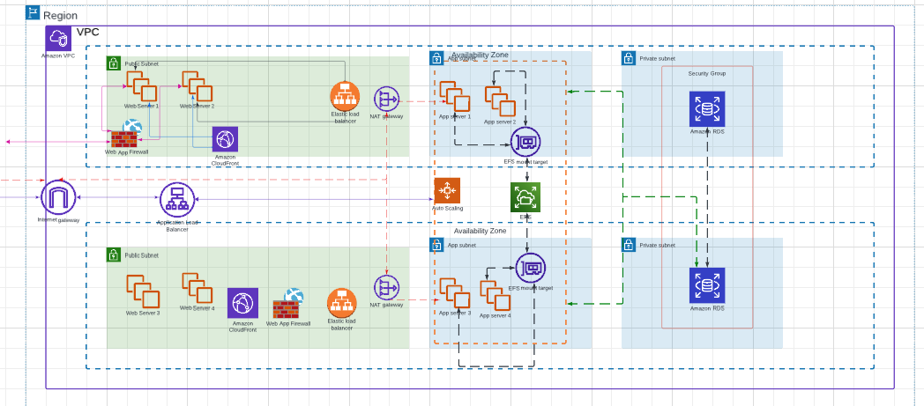

Reason why the selected services of amazon have been chosen over others as it provides a robust and scalable infrastructure for FishTanks PETRA application to fulfil the system currently and the factors that they will require which is performance, security, and cost efficiency.

* Amazon RDS for MySQL:
  + Use Case: Hosting the MySQL database for FishTanks application
  + Reason: RDS provides a fully managed database service platform, with reduction in administrative overhead. Multi-AZ deployment ensures high availability and failover support.
* Amazon Elastic File System (EFS):
  + Use Case: File storage for application data and content. It will be able to store video editing that is the FishTank Media.
  + Reason: EFS is scalable and provides shared file storage across multiple EC2 instances. This is essential for storing data that needs to be accessed by multiple application components.
* Web Application Firewall(WAF):
  + UseCase: Protection of web application from common web exploits.
  + Reason: WAF helps protect against various web-based attack. Configuring rules and the ability to manage rule groups will help enhance security by filtering malicious traffic before reaching the application.
* Amazon CloudFront:
  + UseCase: Content delivery network CDN for fast and secure delivery.
  + Reason: improves latency and delivers content quickly to users globally. Integrating seamlessly with other AWS services and ensuring a better user experience.
* Elastic Load Balancing (ELB):
  + UseCase: Distributing incoming traffic across multiple EC2 instances
  + Reasoning: enhancing fault tolerance and availability through distriubing among healthy instances.
* S3 Amazon Simple Storage Service:
  + Use Case: Object Storage for static assets and backups
  + Reason: Provides scalable, durable and low latency object storage, suitable for large amounts of data, in this case backups and videos for FishTank.
* Amazon EC2:
  + Use Case:
    - Hosting application instances: As Fishtank uses Windows 2012.
    - An EC2 instance may provide the capabilities of running the applications of the Server on the EC2 if need be without the need for configuration.
  + Reason: Scalable computing capacity provision. The selected type is t3.arge is suitable for general purpose workloads. As well as Compute Saving Plans offering cost savings over the option of On-demand pricing.
* Amazon Virtual Private Cloud:
  + Use Case: Create an isolated network environment.
  + Reaso: VPC enables Fishtank to be able to define their chosen network layout or configuration, through route tables that are configurable and control network traffic. It is essential for security and network customization.

Pricing:

According to the context provided by FishTank as well as the VPC architecture detailed above. The monthly running costs are as shown below:

How should you calculate your TCO please look at the AWS TCO methodology:3

AWS Pricing Calculator: 4

The following services were added to the estimate cost calculator pdf:

* Amazon RDS for MySql:
  + Region: US East (N.Virginia)
  + Upfront cost: 0.00 USD
  + Monthly 851.00 USD
  + Configuration Summary:
    - Storage for each RDS instance (General Purpose SSD (gp2)), Storage amount (30 GB), Quantity (1), Instance type (db.m1.large), Utilization (On-Demand only) (100 %Utilized/Month), Deployment option (Multi-AZ), Pricing strategy (OnDemand), Additional backup storage (5 TB)
* Amazon Elastic File:
  + Region: US East (N.Virginia)
  + Upfront cost:0.00 USD
  + Monthly Cost: 1,392.64 USD
  + Configuration Summary:
    - Enter the amount of data (including metadata) that you expect to read from your file system per month (8 TB per month), Enter the amount of data (including metadata) that you expect to write from your file system per month (8 TB per month), Desired Storage Capacity (8 TB per month)
* WAF (Web Application Firewall)
  + Region: US East (N.Virginia)
  + Upfront cost: 0.00 USD
  + Monthly Cost: 36.80 USD
  + Configuration Summary:
    - Number of Rules added per Web ACL (2 per month), Number of Web Access Control Lists (Web ACLs) utilized (2 per month), Number of Rule Groups per Web ACL (2 per month), Number of Rules inside each Rule Group (2 per month), Number of Managed Rule Groups per Web ACL (3 per month)
* CloudFront
  + Region: US East (N.Virginia)
  + Upfront cost:
  + Monthly Cost: 281.61USD
  + Configuration Summary:
    - Data transfer out to internet (3 TB per month), Data transfer out to origin (1 TB per month), Number of requests (HTTPS) (5000 per month)
* Elastic Load Balancing:
  + Region: US East (N.Virginia)
  + Upfront Cost:
  + Monthly Cost:859.94USD
  + Configuration Summary:
    - Number of Application Load Balancers (4)
* Amazon Simple Storage Service (S3)
  + Region: US East (N.Virginia)
  + Upfront Cost:
  + Monthly Cost: 96.97USD
  + Configuration Summary
    - S3 Standard storage (4 TB per month), GET, SELECT, and all other requests from S3 Standard (100), Data returned by S3 Select (1 TB per month), Data scanned by S3 Select (1 TB per month) DT Inbound: Internet (1 TB per month), DT Outbound: Amazon CloudFront (1 TB per month)
* Amazon EC2:
  + Region: US East (N.Virginia)
  + Upfront Cost: 0.00USD
  + Monthly Cost: 1,568.08 USD
  + Configuration Summary:
    - Tenancy (Shared Instances), Operating system (Microsoft Windows Server), Workload (Consistent, Number of instances: 1), Advance EC2 instance (t3.large), Pricing strategy (Compute Savings Plans 1yr No Upfront), Enable monitoring (enabled), EBS Storage amount (1 TB), DT Inbound: Internet (1 TB per month), DT Outbound: Amazon CloudFront (0 TB per month), DT Intra-Region: (1 TB per month)
* Amazon Virtual Private Cloud – for NAT gateways:
  + Region: US East (N.Virginia)
  + Upfront Cost: 0.00USD
  + Monthly Cost: 1192.20 USD
  + Configuration Summary:
    - Working days per month (22), Number of Site-to-Site VPN Connections (4), Number of subnet associations (3) Number of NAT Gateways (2)

The estimated number of people that will be used in accordance to the rates provided:

* Initial Planning Phase:
  + Will require 3 people consisting of
    - Business analyst(x1)
    - Cloud consolutant(x1)
    - Solution architect(x1)
* Migration and Excecution Phase:
  + Will require 4 people consisting of
    - Server Migration Engineer(x2)
    - Database Migration Engineer(x2)
* Ongoing Support:
  + Will require 2 people
    - First/Second Line Cloud Support(x1)
    - Third Line Cloud Support(x1)
* Monthly cost per role:
  + Business Analyst (£400):
    - £400/day * 20 days = £8000/mnth
  + Cloud Consultant (£2000):
    - £400/day * 20 days = £40000/mnth
  + Solution Architect (£1000):
    - £400/day * 20 days = £20000/mnth
  + Server Migration Engineer (£650):
    - £400/day * 20 days = £13000/mnth(per engineer, x2 engineers)
  + Database Migration Engineer (£750):
    - £400/day * 20 days = £15000/mnth(per engineer, x2engineer)
  + Frist/Second Line Cloud Support (£250):
    - £250/day * 20 days = £5000/mnth(x1 engineer)
  + Third Line Support (£350):
    - £350/day * 20 days = £7000/mnth(x1 engineer)
* Total Monthly Cost:
  + Initial Planning Phase:
    - Business Analyst + Cloud Consultant + Solution Architect = £68,000/month
  + Migration and Execution Phase:
    - Server Migration Engineers + Database Migration Engineers = £56,000/month
  + Ongoing Support:
    - First/Second Line Cloud Support + Third Line Cloud Support = £12,000/month
* Grand Total Monthly Cost:
* £68,000 (Initial Planning) + £56,000 (Migration Execution) + £12,000 (Ongoing Support) = £136,000/month

Please Note this is subject to change if need be and can be discussed to suit FishTank’s needs.

References:

1. ‘Migrating you existing Applications to the AWS cloud- A Phase-driven Approach to Cloud Migration- Jinesh Varia’’. https://d1.awsstatic.com/whitepapers/cloud-migration-main.pdf
2. (<https://www.youtube.com/watch?v=AXQ7n7rDfFE>)
3. <https://pages.awscloud.com/rs/112-TZM-766/images/Cloud%20Economics%20Ebook_October%202018.pdf>
4. AWS Pricing Calculator docs: <https://docs.aws.amazon.com/pricing-calculator/latest/userguide/what-is-pricing-calculator.html>
5. Lab2: AWS Solutions Architect